SCHOOL OF COMPUTER SCIENCE AND ARTIFICIAL INTELLIGENCE |  |  |  |  | DEPARTMENT OF COMPUTER SCIENCE ENGINEERING
Program Name: B. Tech |  |  |  | Assignment Type: Lab |  |  | Academic Year:2025-2026
Instructor(s) Name |  |  |  | S Naresh Kumar
Course Code |  |  | 24CS002PC215 | Course Title |  | AI Assisted Coding
Year/Sem |  |  | II/III | Regulation |  | R24
Date and Day  of Assignment |  |  | Week3 – Monday | Time(s)
Duration |  |  | 2 Hours | Applicable to  Batches
Assignment Number:5.1 and 6(Present assignment number)/24(Total number of assignments)
 | Q.No. | Question |  |  |  |  |  | Expected Time  to complete
 |  | Task 1:  Employee Data: Create Python code that defines a class named `Employee` with the following attributes: `empid`, `empname`, `designation`, `basic_salary`, and `exp`. Implement a method `display_details()` to print all employee details. Implement another method `calculate_allowance()` to determine additional allowance based on experience:  - If `exp > 10 years` → allowance = 20% of `basic_salary`  - If `5 ≤ exp ≤ 10 years` → allowance = 10% of `basic_salary`  - If `exp < 5 years` → allowance = 5% of `basic_salary`  Finally, create at least one instance of the `Employee` class, call the `display_details()` method, and print the calculated allowance.  Code:  class Employee:  def __init__(self, emp_id, emp_name, emp_salary, designation, basic_salary, experience):  self.emp_id = emp_id  self.emp_name = emp_name  self.emp_salary = emp_salary  self.designation = designation  self.basic_salary = basic_salary  self.experience = experience  def display_details(self):  print(f"Employee ID: {self.emp_id}")  print(f"Employee Name: {self.emp_name}")  print(f"Employee Salary: {self.emp_salary}")  print(f"Designation: {self.designation}")  print(f"Basic Salary: {self.basic_salary}")  print(f"Experience: {self.experience} years")  def calculate_allowance(self):  if self.experience > 10:  allowance = 0.20 * self.basic_salary  elif 5 <= self.experience <= 10:  allowance = 0.10 * self.basic_salary  else:  allowance = 0.05 * self.basic_salary  return allowance  # Creating an instance of Employee  employee = Employee(emp_id=101, emp_name="John Doe", emp_salary=75000  , designation="Software Engineer", basic_salary=60000, experience=8)  employee1 = Employee(emp_id=102, emp_name="Jane Smith", emp_salary=85000  , designation="Senior Developer", basic_salary=70000, experience=12)  employee2 = Employee(emp_id=103, emp_name="Alice Johnson", emp_salary=50000  , designation="Junior Developer", basic_salary=40000, experience=3)  employee3 = Employee(emp_id=104, emp_name="Bob Brown", emp_salary=95000  , designation="Team Lead", basic_salary=80000, experience=15)  # Displaying employee details  employee.display_details()  # Calculating and printing allowance  allowance = employee.calculate_allowance()  print(f"Calculated Allowance: {allowance}")  print("\n")  employee1.display_details()  allowance1 = employee1.calculate_allowance()  print(f"Calculated Allowance: {allowance1}")  print("\n")  employee2.display_details()  allowance2 = employee2.calculate_allowance()  print(f"Calculated Allowance: {allowance2}")  print("\n")  employee3.display_details()  allowance3 = employee3.calculate_allowance()  print(f"Calculated Allowance: {allowance3}")  # Analysis:  # Time Complexity: O(1) - The operations in the methods are constant time operations.  # Space Complexity: O(1) - The space used by the instance variables is constant.  # Compare this snippet from Assignment6/Task10.py:  Output  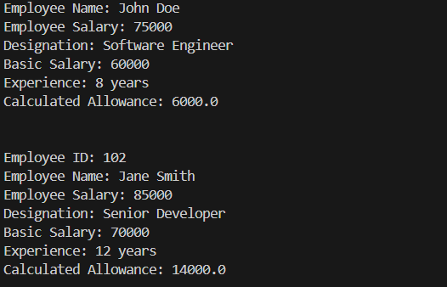  Explanation  Task 2:  Electricity Bill Calculation- Create Python code that defines a class named `ElectricityBill` with attributes: `customer_id`, `name`, and `units_consumed`. Implement a method `display_details()` to print customer details, and a method `calculate_bill()` where:  - Units ≤ 100 → ₹5 per unit  - 101 to 300 units → ₹7 per unit  - More than 300 units → ₹10 per unit  Create a bill object, display details, and print the total bill amount.  Code  class ElectricityBill:  def __init__(self, customer_id, name, units_consumed):  self.customer_id = customer_id  self.name = name  self.units_consumed = units_consumed  def display_details(self):  print(f"Customer ID: {self.customer_id}")  print(f"Name: {self.name}")  print(f"Units Consumed: {self.units_consumed}")  def calculate_bill(self):  if self.units_consumed <= 100:  rate_per_unit = 5  elif 101 <= self.units_consumed <= 300:  rate_per_unit = 7  else:  rate_per_unit = 10  total_bill = self.units_consumed * rate_per_unit  return total_bill  # Creating an instance of ElectricityBill  bill = ElectricityBill(customer_id=1, name="Alice", units_consumed=250)  # Displaying customer details  bill.display_details()  # Calculating and printing total bill amount  total_amount = bill.calculate_bill()  print(f"Total Bill Amount: ₹{total_amount}")  Output  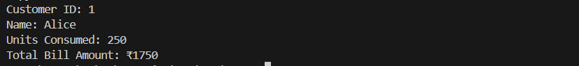  Explanation  Task 3:  Product Discount Calculation- Create Python code that defines a class named `Product` with attributes: `product_id`, `product_name`, `price`, and `category`. Implement a method `display_details()` to print product details. Implement another method `calculate_discount()` where:  - Electronics → 10% discount  - Clothing → 15% discount  - Grocery → 5% discount  Create at least one product object, display details, and print the final price after discount.  Code  class Product:  def __init__(self, product_id, product_name, price, category):  self.product_id = product_id  self.product_name = product_name  self.price = price  self.category = category  def display_details(self):  print(f"Product ID: {self.product_id}")  print(f"Product Name: {self.product_name}")  print(f"Price: ₹{self.price}")  print(f"Category: {self.category}")  def calculate_discount(self):  if self.category == "Electronics":  discount_rate = 0.10  elif self.category == "Clothing":  discount_rate = 0.15  elif self.category == "Grocery":  discount_rate = 0.05  else:  discount_rate = 0.0 # No discount for other categories  final_price = self.price * (1 - discount_rate)  return final_price  # Creating an instance of Product  product = Product(product_id=101, product_name="Smartphone", price=20000,  category="Electronics")  # Displaying product details  product.display_details()  # Calculating and printing final price after discount  final_price = product.calculate_discount()  print(f"Final Price after discount: ₹{final_price}")  Output  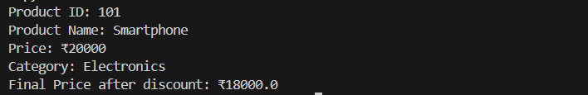  Explanation  Task 4:  Book Late Fee Calculation- Create Python code that defines a class named `LibraryBook` with attributes: `book_id`, `title`, `author`, `borrower`, and `days_late`. Implement a method `display_details()` to print book details, and a method `calculate_late_fee()` where:  - Days late ≤ 5 → ₹5 per day  - 6 to 10 days late → ₹7 per day  - More than 10 days late → ₹10 per day  Create a book object, display details, and print the late fee.  Code  class LibraryBook:  def __init__(self, book_id, title, author, borrower, days_late):  self.book_id = book_id  self.title = title  self.author = author  self.borrower = borrower  self.days_late = days_late  def display_details(self):  print(f"Book ID: {self.book_id}")  print(f"Title: {self.title}")  print(f"Author: {self.author}")  print(f"Borrower: {self.borrower}")  print(f"Days Late: {self.days_late}")  def calculate_late_fee(self):  if self.days_late <= 5:  fee_per_day = 5  elif 6 <= self.days_late <= 10:  fee_per_day = 7  else:  fee_per_day = 10  total_fee = self.days_late * fee_per_day  return total_fee  # Creating an instance of LibraryBook  book = LibraryBook(book_id=1, title="The Great Gatsby", author="F. Scott Fitzgerald",  borrower="John Doe", days_late=8)  # Displaying book details  book.display_details()  # Calculating and printing late fee  late_fee = book.calculate_late_fee()  print(f"Late Fee: ₹{late_fee}")  # Analysis:  # Time Complexity: O(1) - Both methods perform a constant number of operations.  Output  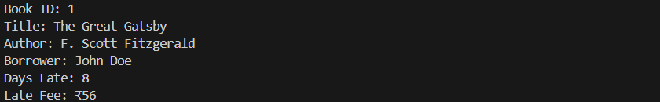  Explanation  Task 5:  Student Performance Report - Define a function `student_report(student_data)` that accepts a dictionary containing student names and their marks. The function should:  - Calculate the average score for each student  - Determine pass/fail status (pass ≥ 40)  - Return a summary report as a list of dictionaries  Use Copilot suggestions as you build the function and format the output.  Code  def student_report(student_data):  report = []  for student, marks in student_data.items():  average_score = sum(marks) / len(marks)  status = "Pass" if average_score >= 40 else "Fail"  report.append({  "name": student,  "average_score": average_score,  "status": status  })  return report  # Example usage  if __name__ == "__main__":  student_data = {  "Alice": [85, 92, 78],  "Bob": [58, 64, 70],  "Charlie": [35, 40, 30]  }  summary_report = student_report(student_data)  for student in summary_report:  print(f"Name: {student['name']}, Average Score: {student['average_score']:.2f}, Status: {student['status']}")  # Analysis:  # Time Complexity: O(n) - where n is the number of students, as we iterate  Output  Explanation  Task 6:  Taxi Fare Calculation-Create Python code that defines a class named `TaxiRide` with attributes: `ride_id`, `driver_name`, `distance_km`, and `waiting_time_min`. Implement a method `display_details()` to print ride details, and a method `calculate_fare()` where:  - ₹15 per km for the first 10 km  - ₹12 per km for the next 20 km  - ₹10 per km above 30 km  - Waiting charge: ₹2 per minute  Create a ride object, display details, and print the total fare.  Code  class TaxiRide:  def __init__(self, ride_id, driver_name, distance_km, waiting_time_min):  self.ride_id = ride_id  self.driver_name = driver_name  self.distance_km = distance_km  self.waiting_time_min = waiting_time_min  def display_details(self):  print(f"Ride ID: {self.ride_id}")  print(f"Driver Name: {self.driver_name}")  print(f"Distance (km): {self.distance_km}")  print(f"Waiting Time (min): {self.waiting_time_min}")  def calculate_fare(self):  fare = 0  if self.distance_km <= 10:  fare += self.distance_km * 15  elif 10 < self.distance_km <= 30:  fare += 10 * 15 + (self.distance_km - 10) * 12  else:  fare += 10 * 15 + 20 * 12 + (self.distance_km - 30) * 10  fare += self.waiting_time_min * 2  return fare  # Creating an instance of TaxiRide  ride = TaxiRide(ride_id=1, driver_name="Rajesh", distance_km  =35, waiting_time_min=15)  # Displaying ride details  ride.display_details()  # Calculating and printing total fare  total_fare = ride.calculate_fare()  print(f"Total Fare: ₹{total_fare}")  Output  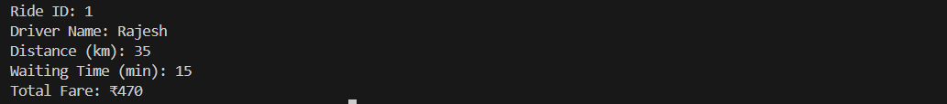  Explanation  Task 7:  Statistics Subject Performance - Create a Python function `statistics_subject(scores_list)` that accepts a list of 60 student scores and computes key performance statistics. The function should return the following:  - Highest score in the class  - Lowest score in the class  - Class average score  - Number of students passed (score ≥ 40)  - Number of students failed (score < 40)  Allow Copilot to assist with aggregations and logic  Code  def statistics_subject(scores_list):  highest_score = max(scores_list)  lowest_score = min(scores_list)  average_score = sum(scores_list) / len(scores_list)  passed_count = sum(1 for score in scores_list if score >= 40)  failed_count = sum(1 for score in scores_list if score < 40)  return {  "highest_score": highest_score,  "lowest_score": lowest_score,  "average_score": average_score,  "passed_count": passed_count,  "failed_count": failed_count  }  # Example usage  if __name__ == "__main__":  scores = [55, 67, 45, 23, 89, 90, 34, 76, 88, 92,  41, 39, 60, 72, 81, 33, 49, 58, 77, 84,  91, 38, 44, 53, 66, 70, 79, 82, 95, 100,  29, 31, 36, 42, 47, 50, 54, 61, 65, 68,  74, 80, 85, 87, 93, 96, 98, 22, 25, 27,  30, 32, 35, 37, 40, 43, 46, 48, 51, 52]  stats = statistics_subject(scores)  print(f"Highest Score: {stats['highest_score']}")  print(f"Lowest Score: {stats['lowest_score']}")  print(f"Average Score: {stats['average_score']:.2f}")  print(f"Number of Students Passed: {stats['passed_count']}")  print(f"Number of Students Failed: {stats['failed_count']}")  Output  Explanation |  |  |  |  |  | Week3 - Monday
Lab 5: Ethical Foundations – Responsible AI Coding Practices
Lab Objectives:
- To explore the ethical risks associated with AI-generated code.
- To recognize issues related to security, bias, transparency, and copyright.
- To reflect on the responsibilities of developers when using AI tools in software development.
- To promote awareness of best practices for responsible and ethical AI coding.
Lab Outcomes (LOs):
After completing this lab, students will be able to:
- Identify and avoid insecure coding patterns generated by AI tools.
- Detect and analyze potential bias or discriminatory logic in AI-generated outputs.
- Evaluate originality and licensing concerns in reused AI-generated code.
- Understand the importance of explainability and transparency in AI-assisted programming.
- Reflect on accountability and the human role in ethical AI coding practices.

Task Description #8 (Transparency in Algorithm Optimization)
Task: Use AI to generate two solutions for checking prime numbers:
- Naive approach(basic)
- Optimized approach
Prompt:
“Generate Python code for two prime-checking methods and explain how the optimized version improves performance.”
Expected Output:
- Code for both methods.
- Transparent explanation of time complexity.
- Comparison highlighting efficiency improvements.
Code
# genrate well commentes code to Check Prime Number
def is_prime_naive(n):
"""Check if a number is prime using the naive approach."""
if n <= 1:
return False
for i in range(2, n):
if n % i == 0:
return False
return True
# Optimized Approach to Check Prime Number
def is_prime_optimized(n):
"""Check if a number is prime using the optimized approach."""
if n <= 1:
return False
if n <= 3:
return True
if n % 2 == 0 or n % 3 == 0:
return False
i = 5
while i * i <= n:
if n % i == 0 or n % (i + 2) == 0:
return False
i += 6
return True
# Example usage
if __name__ == "__main__":
number = int(input("Enter a number to check if it's prime: "))

# Using Naive Approach
if is_prime_naive(number):
print(f"{number} is a prime number (Naive Approach).")
else:
print(f"{number} is not a prime number (Naive Approach).")

# Using Optimized Approach
if is_prime_optimized(number):
print(f"{number} is a prime number (Optimized Approach).")
else:
print(f"{number} is not a prime number (Optimized Approach).")
# Analysis:
# Time Complexity:
# Naive Approach: O(n) - In the worst case, we check all numbers from 2 to n-1.
# Optimized Approach: O(√n) - We only check up to the square root of n and skip even numbers after checking for 2 and 3.
# The optimized approach significantly reduces the number of iterations needed to determine if a number is prime, especially for large values of n.
# Space Complexity:
# Both approaches have a space complexity of O(1) as they use a constant amount of space.

Output
Explanation

Task Description #9 (Transparency in Recursive Algorithms)
Objective: Use AI to generate a recursive function to calculate Fibonacci numbers.
Instructions:
- Ask AI to add clear comments explaining recursion.
- Ask AI to explain base cases and recursive calls.
Expected Output:
- Well-commented recursive code.
- Clear explanation of how recursion works.
- Verification that explanation matches actual execution.
Code
#genrate well commentes code for fibonacci series using recursion
def fibonacci(n):
"""Generate Fibonacci series up to n terms using recursion."""
# Base cases
if n <= 0:
return []
elif n == 1:
return [0]
elif n == 2:
return [0, 1]
else:
fib_series = fibonacci(n - 1)
next_value = fib_series[-1] + fib_series[-2]
fib_series.append(next_value)
return fib_series
# Example usage
if __name__ == "__main__":
terms = int(input("Enter the number of terms for Fibonacci series: "))
series = fibonacci(terms)
print(f"Fibonacci series up to {terms} terms: {series}")

Output
Explanation

Task Description #10 (Transparency in Error Handling)
Task: Use AI to generate a Python program that reads a file and processes data.
Prompt:
“Generate code with proper error handling and clear explanations for each exception.”
Expected Output:
- Code with meaningful exception handling.
- Clear comments explaining each error scenario.
- Validation that explanations align with runtime behavior.

Code
# Generate well-commented code to read a file and process data with error handling
def read_and_process_file(file_path):
"""Read a file and process its data with proper error handling."""
try:
# Attempt to open the file
with open(file_path, 'r') as file:
data = file.readlines()

# Process the data (for example, converting each line to an integer)
processed_data = []
for line in data:
try:
number = int(line.strip())
processed_data.append(number)
except ValueError:
# Handle the case where conversion to integer fails
print(f"Warning: Could not convert line to integer: '{line.strip()}'")

return processed_data

except FileNotFoundError:
# Handle the case where the file does not exist
print(f"Error: The file '{file_path}' was not found.")
except PermissionError:
# Handle the case where there are permission issues
print(f"Error: Permission denied when trying to read the file '{file_path}'.")
except Exception as e:
# Handle any other unexpected exceptions
print(f"An unexpected error occurred: {e}")
# Example usage
if __name__ == "__main__":
file_path = 'Assigment5/data.txt' # Replace with your file path
result = read_and_process_file(file_path)
if result is not None:
print("Processed Data:", result)
# Analysis:
# Time Complexity: O(n) - where n is the number of lines in the file,
# as we read and process each line once.
# Space Complexity: O(m) - where m is the number of successfully processed
# lines, as we store them in a list.

Output

